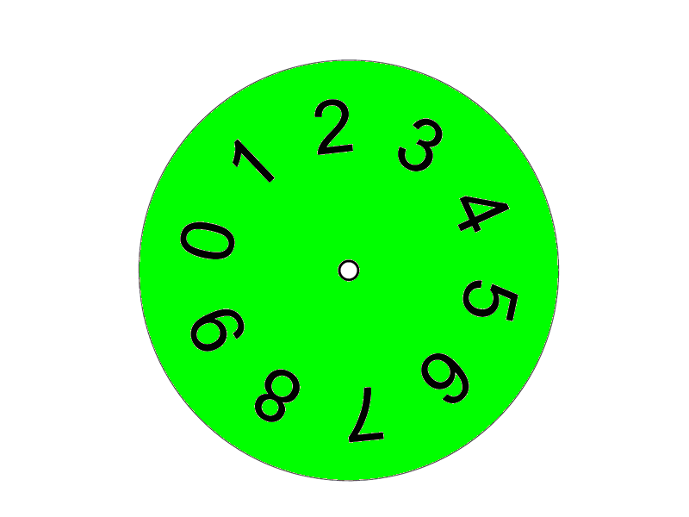

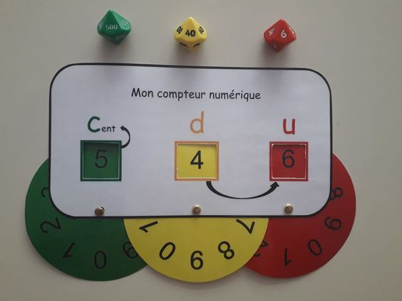

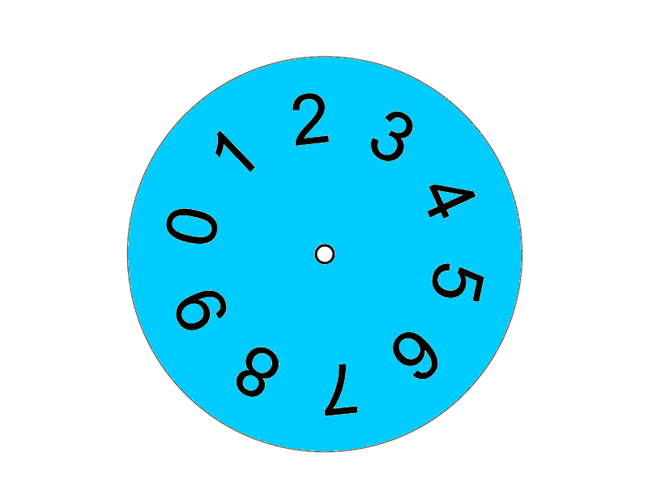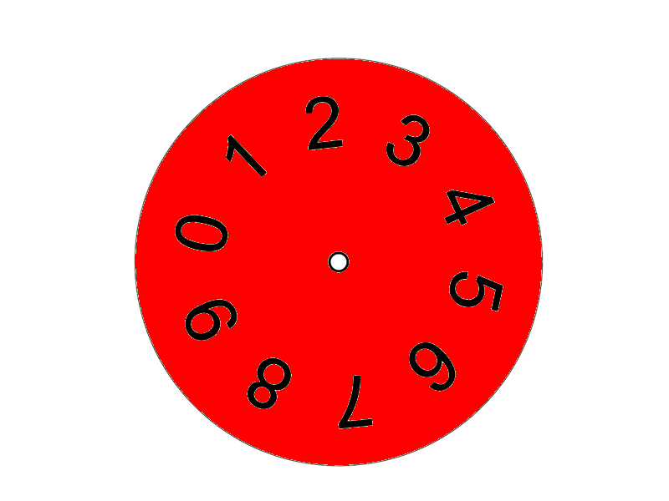

|  |  |  |  |  |  |  |
| --- | --- | --- | --- | --- | --- | --- |
|  |  | Mon compteur numérique | | |  |  |
|  | cent |  | d |  | u |  |
|  |  |  |  |  |  |  |